Creation of Resource Group

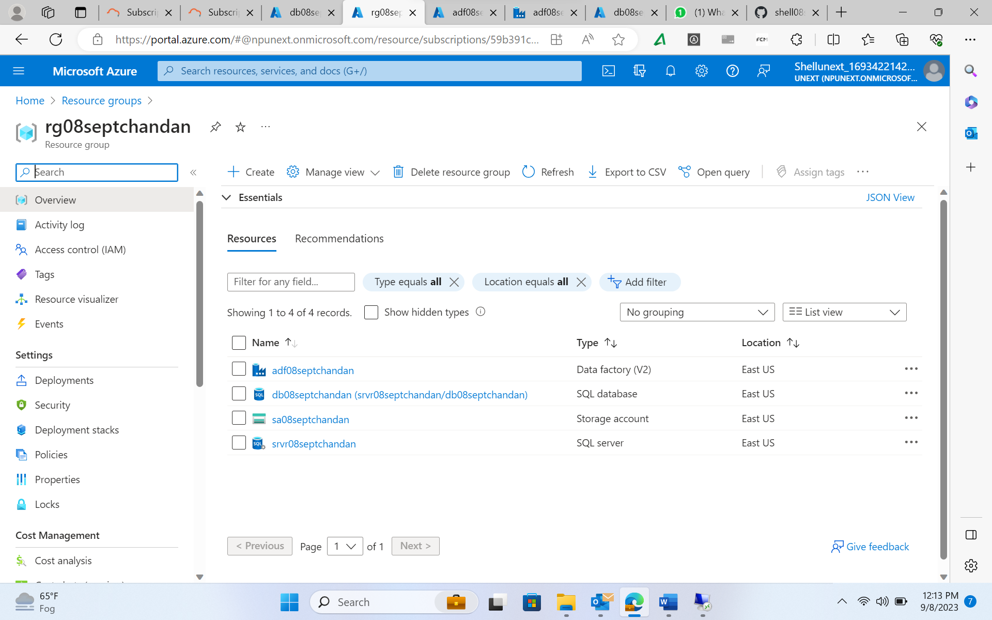

Creation of Storage Account

* Container
  + Input
  + output

Creation of Azure Data Factory

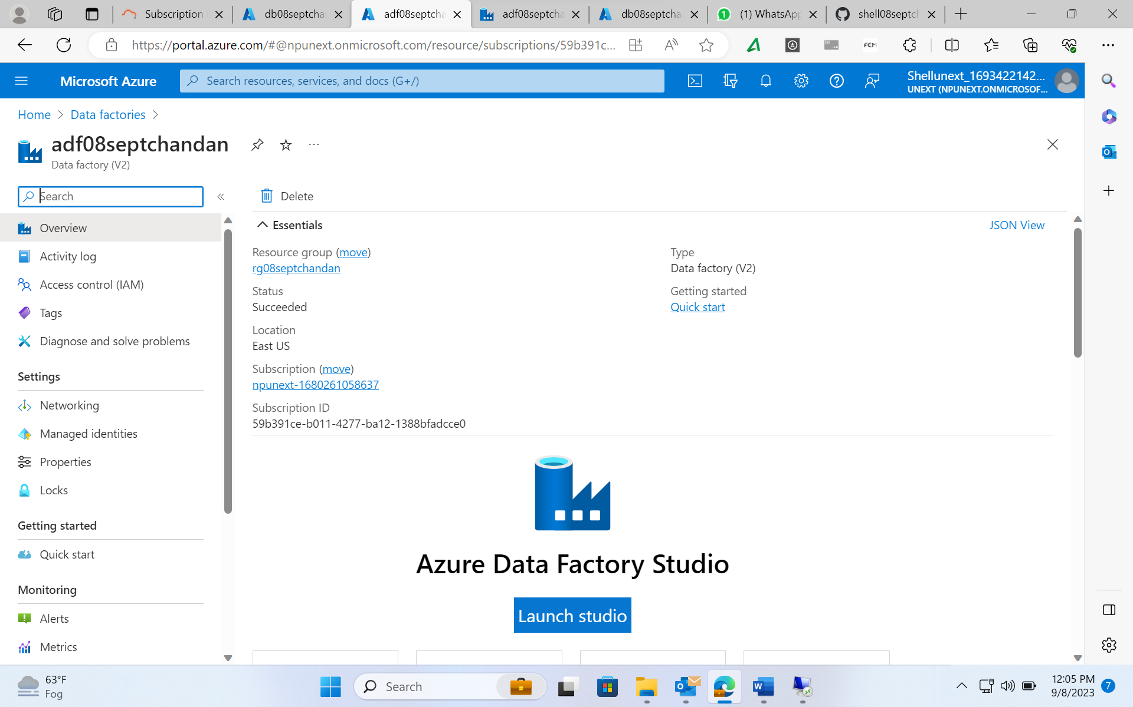

Creation of Azure SQL Database

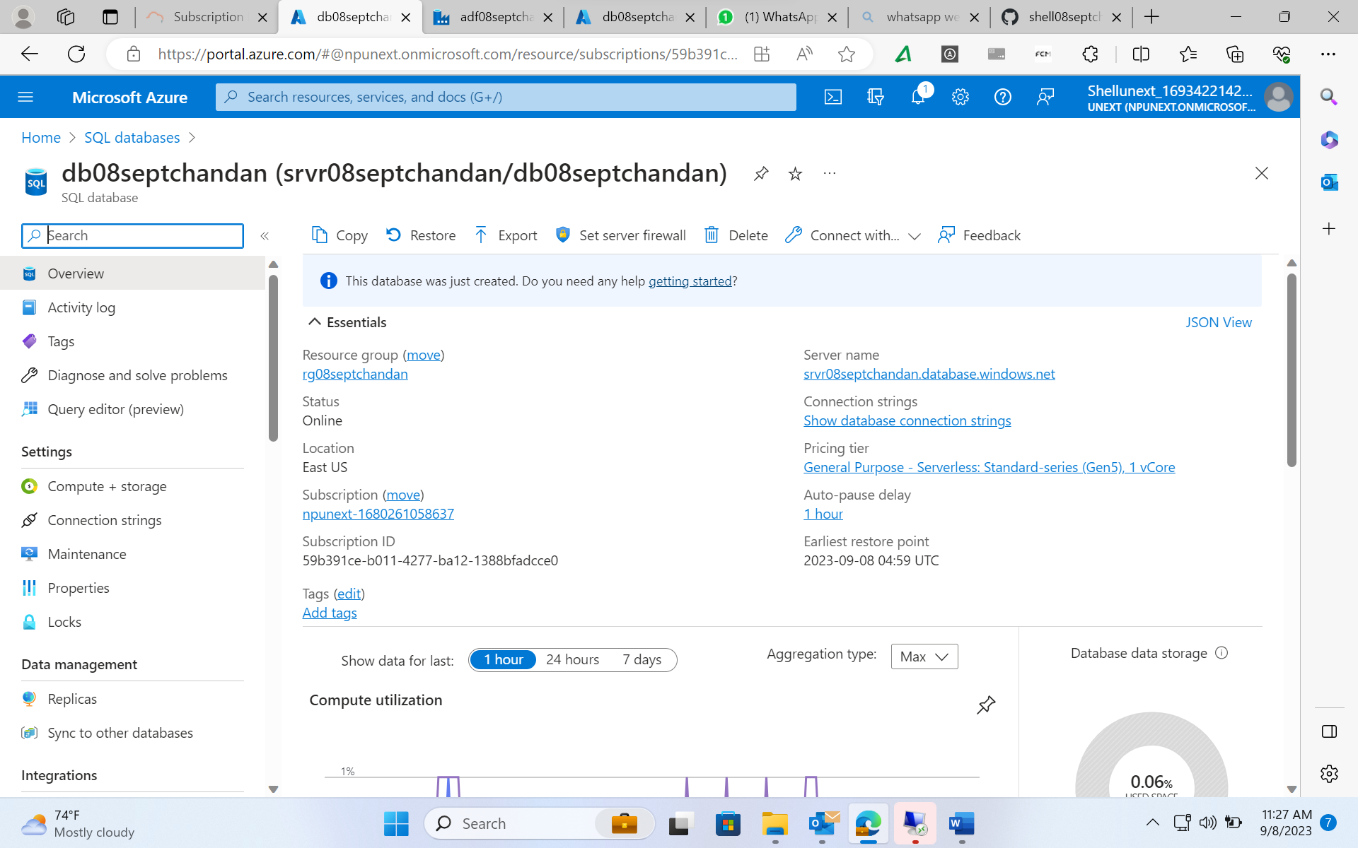

Basics:

* SQL Server
  + Server name: server name
  + Authentication mode: sql authentication (username, password)
* Database
  + Name
  + Workload env: dev

Networking

* Network connectivity
  + Connectivity method: public endpoint
* Firewall rules
  + Allow Azure services and resources to access this server - yes
  + Allow Azure services and resources to access this server – yes

SQL database Client

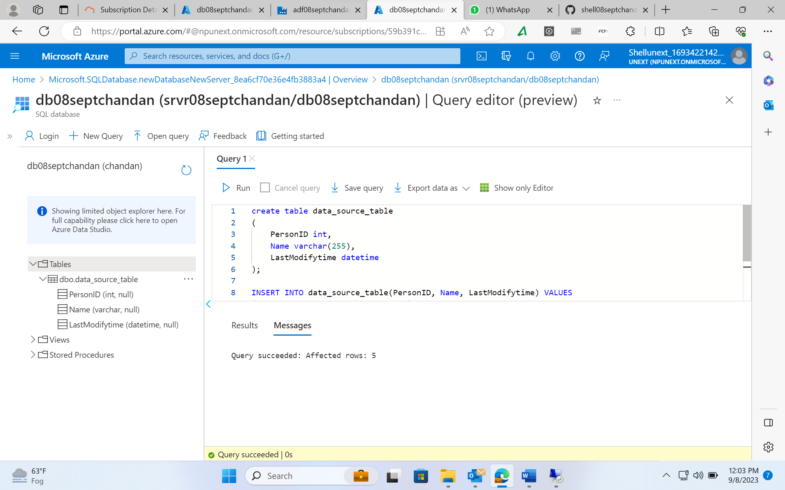

Pipeline creation for copying SQL data to Storage Account

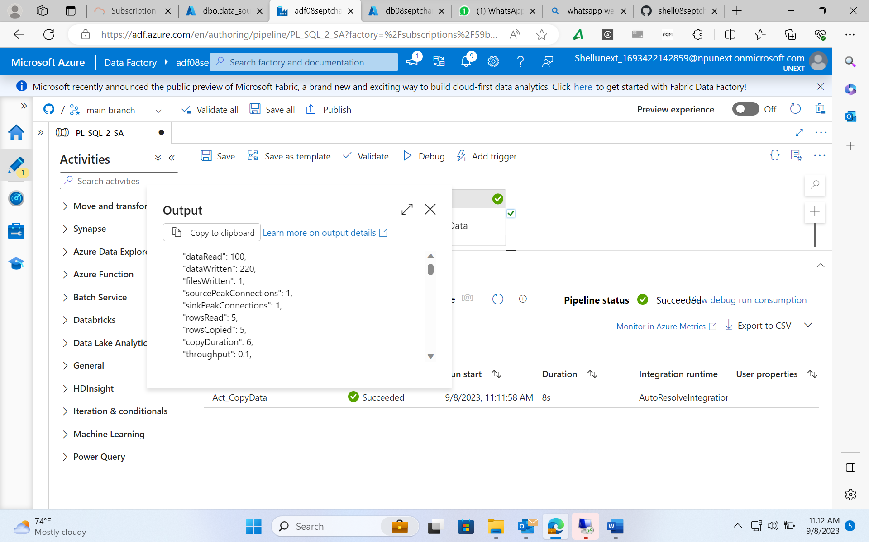

Output: Data in output container:

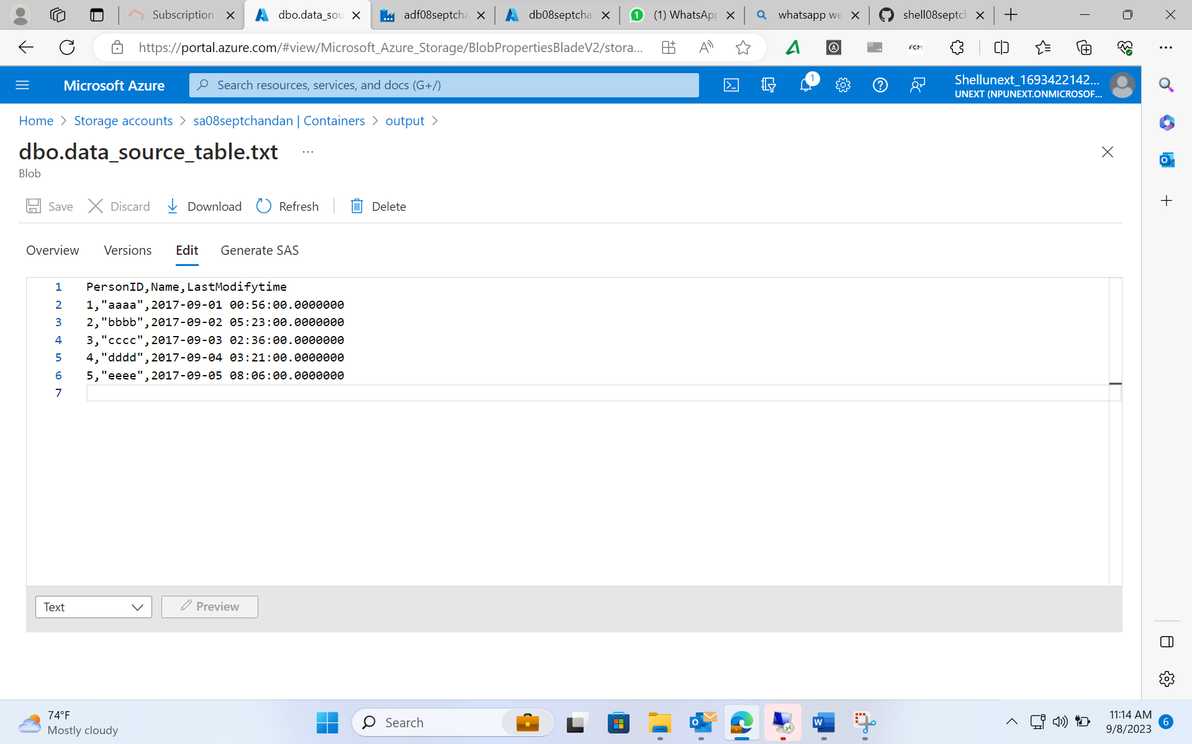

Pipe line creation and copy activity for fetching sql data using query and saving to sa container

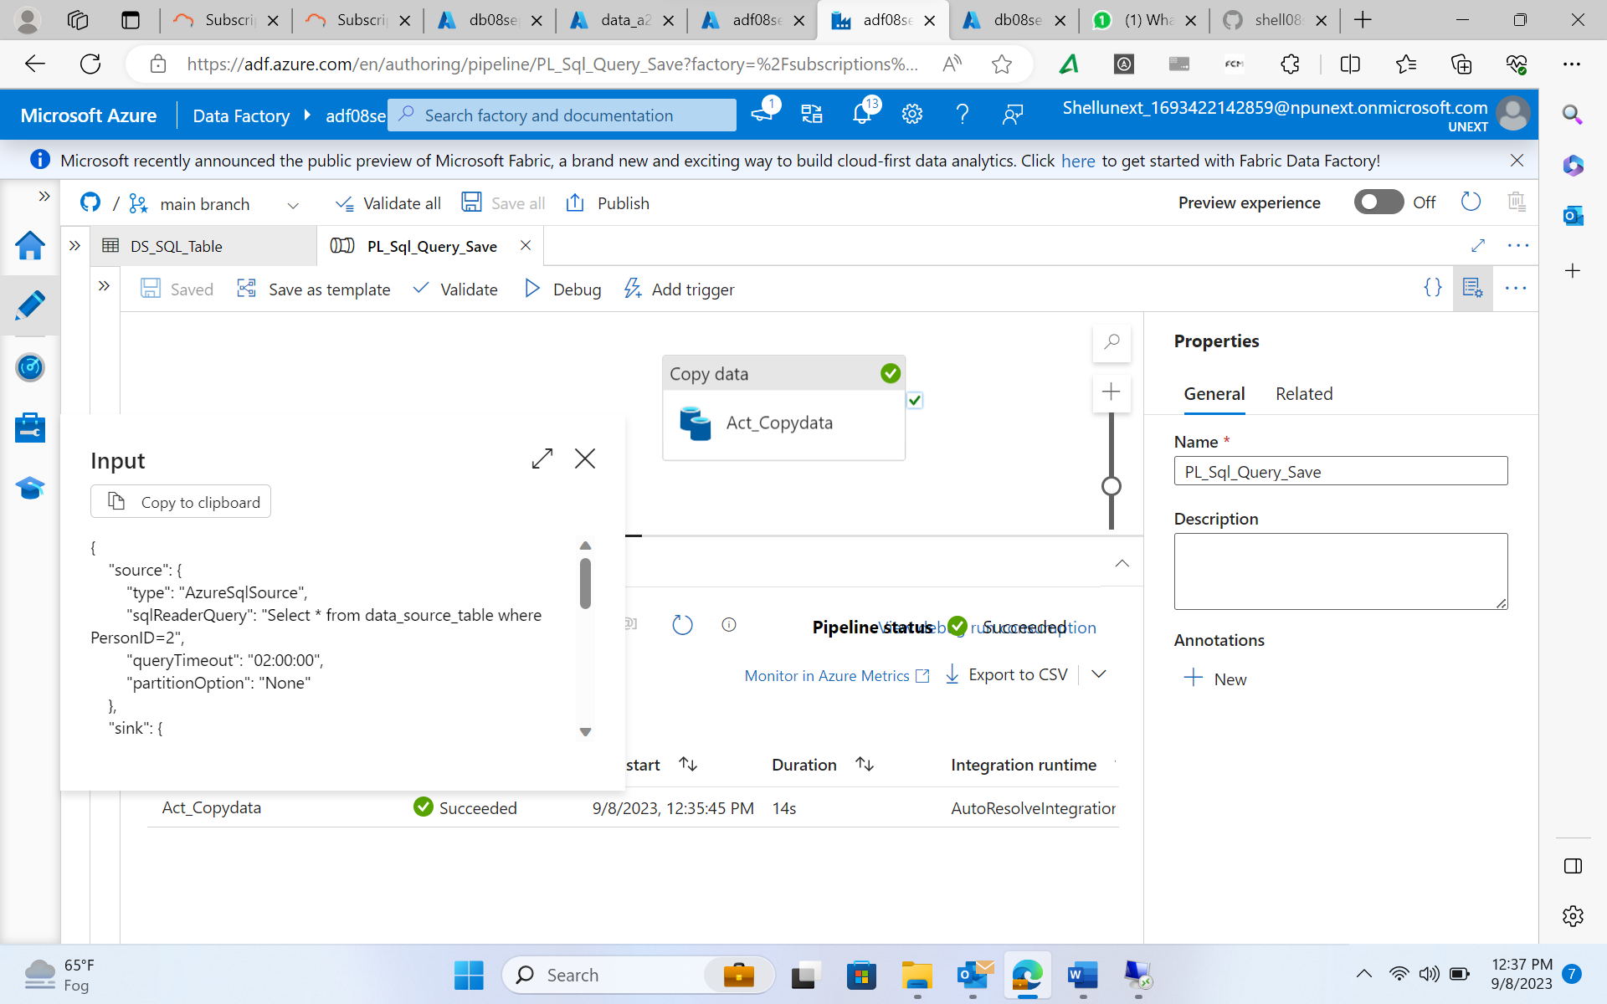

Output: data in output container:

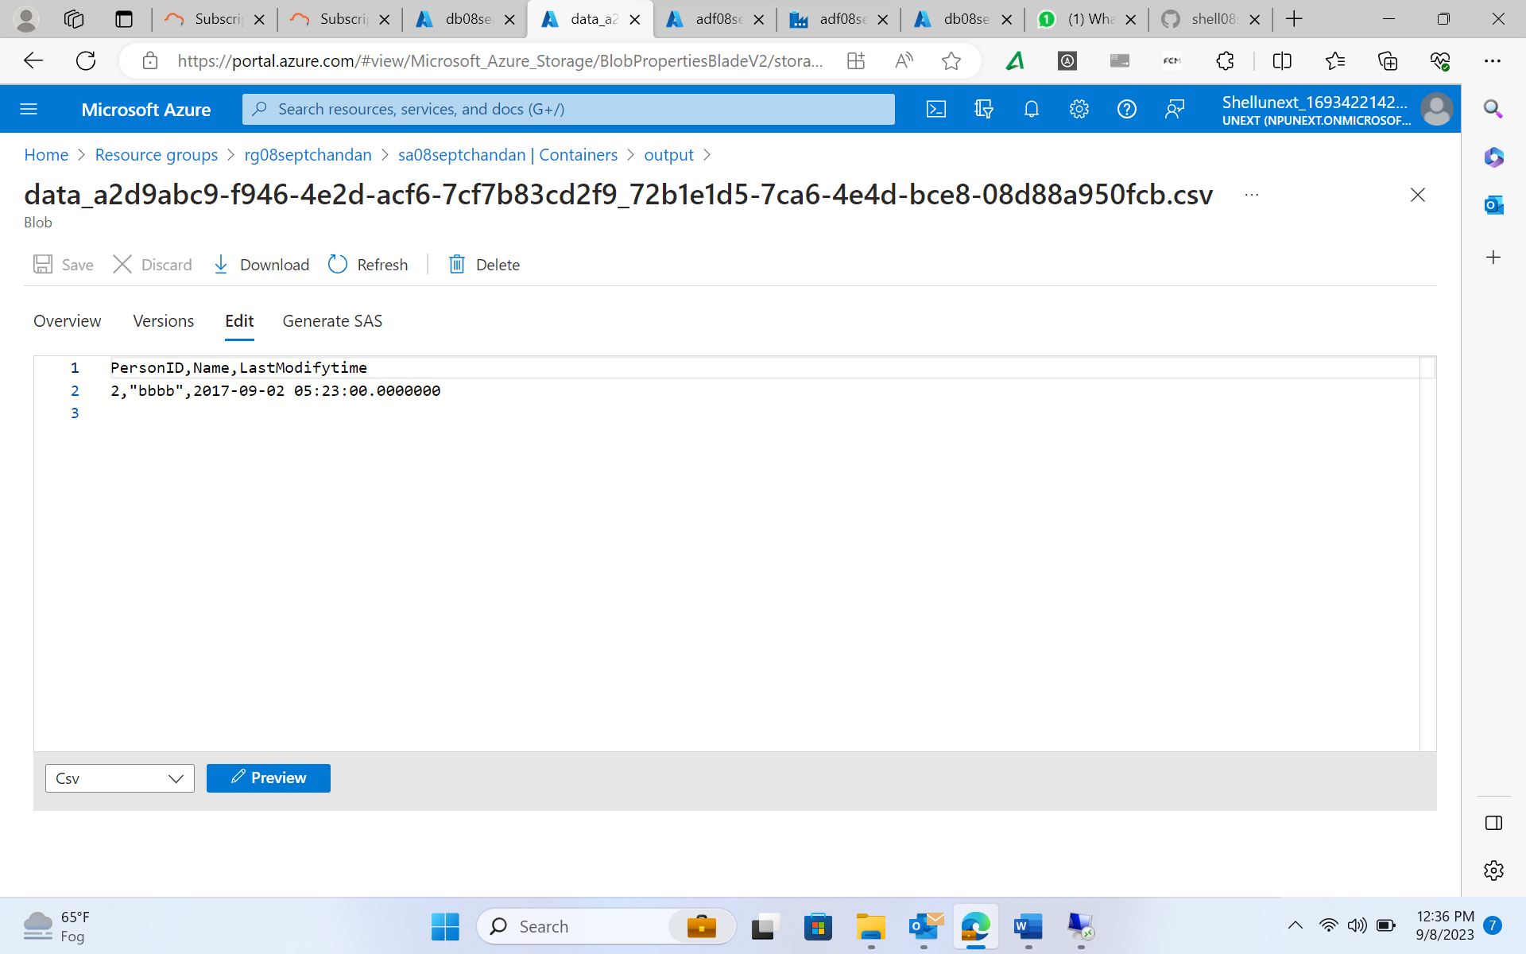

Copy activity 2: copy by calling storedprocedure and save it in sa

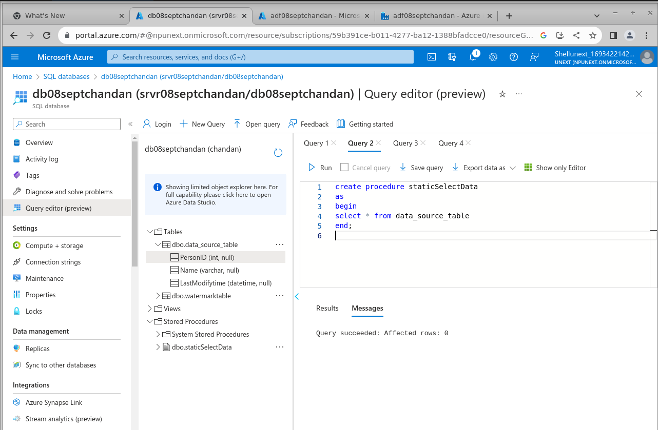

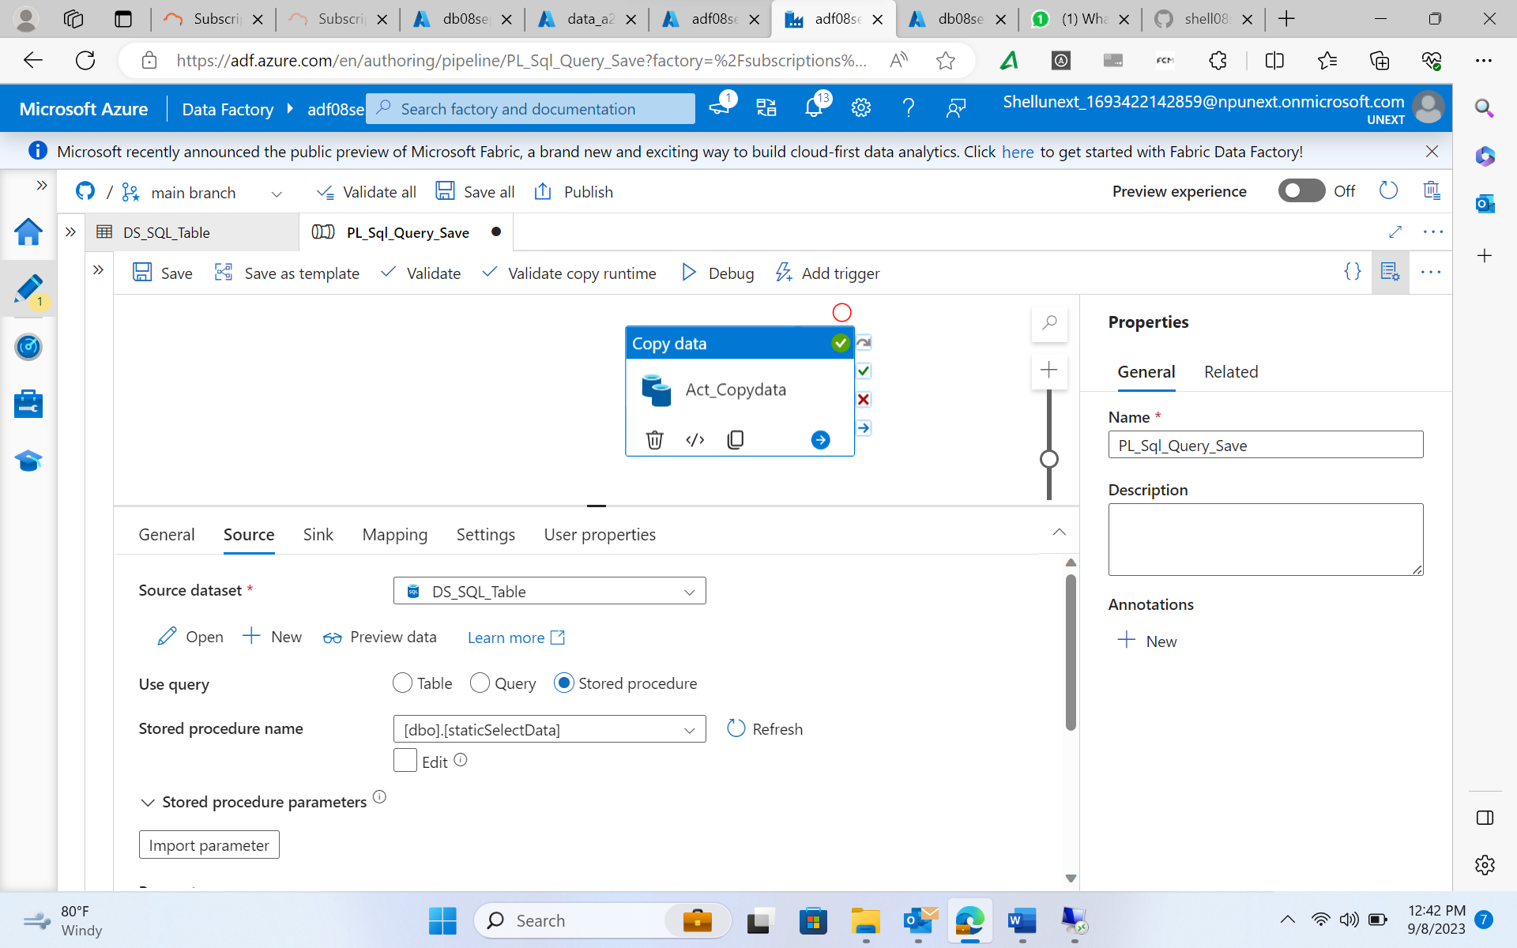

Output:

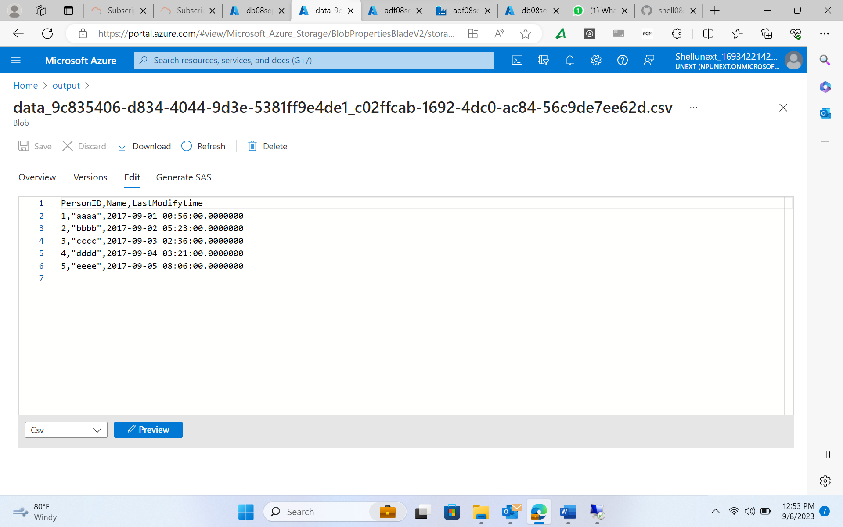

Tracking changes activity CDC(capture data change)

* To sync real time incoming data, it needs to append the changed data from sql to csv.
* For this, one need to maintain a watermark table with tablename updated and the timestamp

Create Dynamic SP to store the metadata about the table that is changed and the timestamp of change.

creating dynamic stored procedure

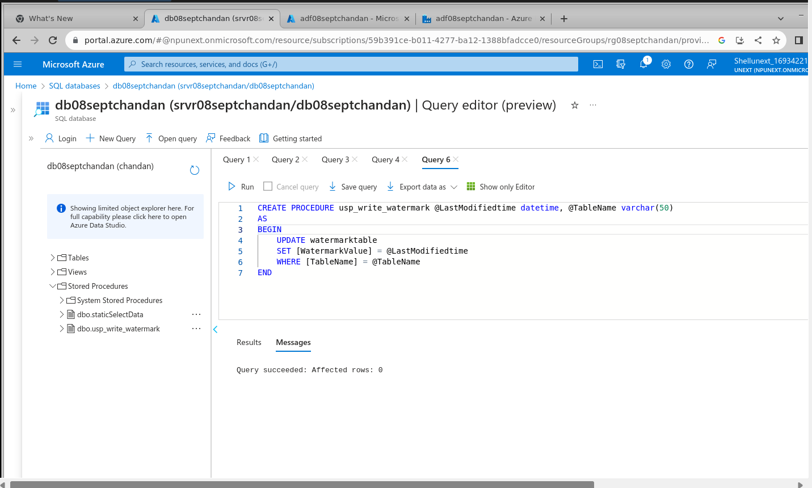

Lookup activity:

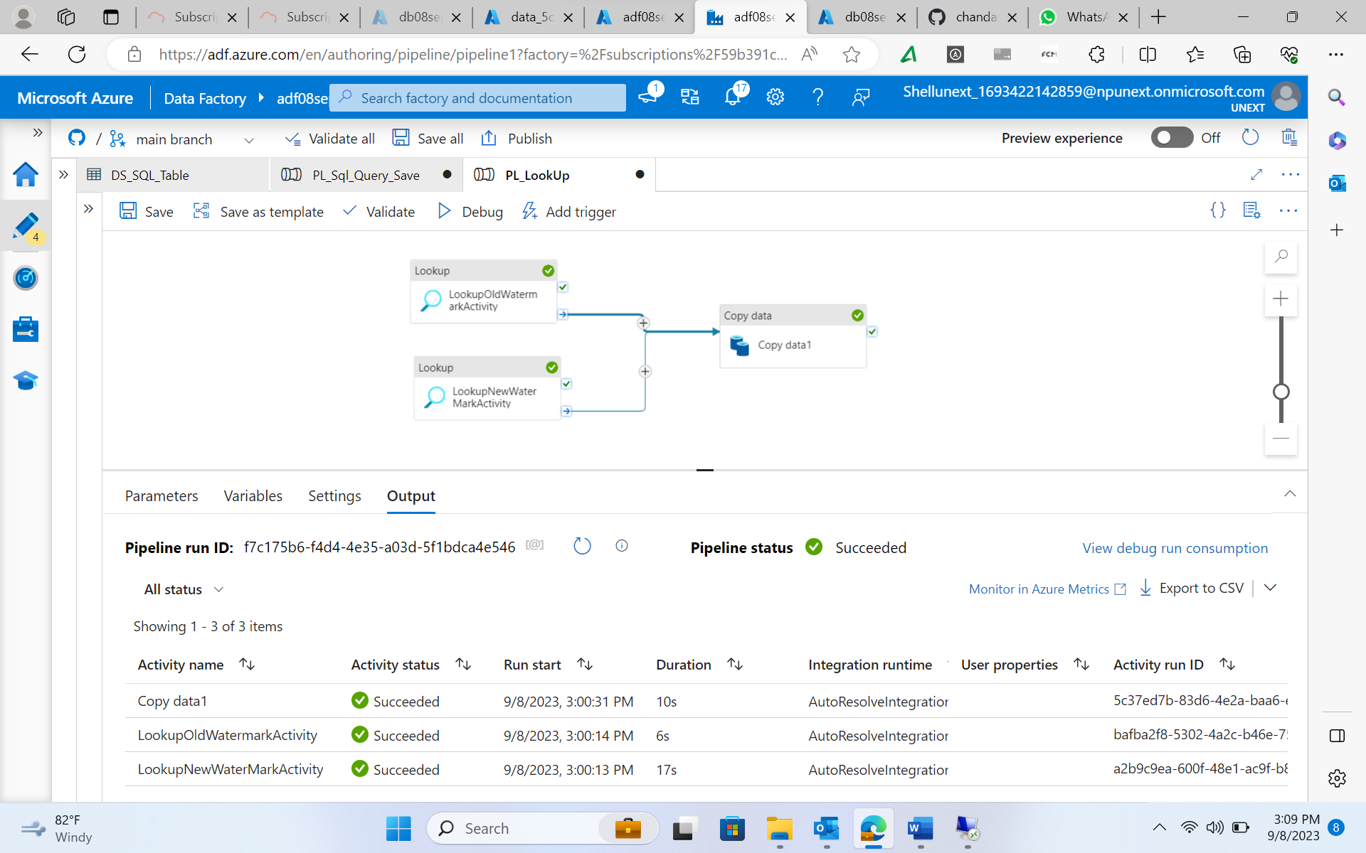

Success:

